MSE1: Cloud Foundations (AI103E)

Lab Exercise 1: Host a Static Webpage on Amazon EC2
Instructions:
- Hosted webpage should have
  - <h1>AWS EC2 Static Website</h1>
  - <p>Name: Your Name</p>
  - <p>Roll Number: Your Roll Number</p>
- Submit the following in a word file:
  - Screenshot of EC2 instance running which also shows Public IP.
  - Screenshot of hosted webpage opened in browser with Public IP.
  - EC2 Public IP address
Note: Do not delete or stop the hosted instance till 9 PM today.

Solution:

- Screenshot of EC2 instance running which also shows Public IP.
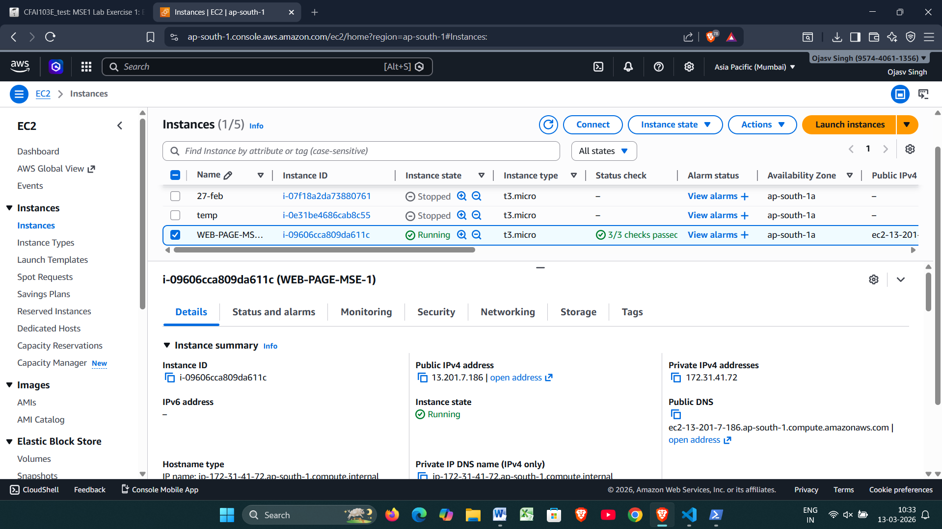

- Screenshot of webpage opened in browser with Public IP & clear content as described in instructions.
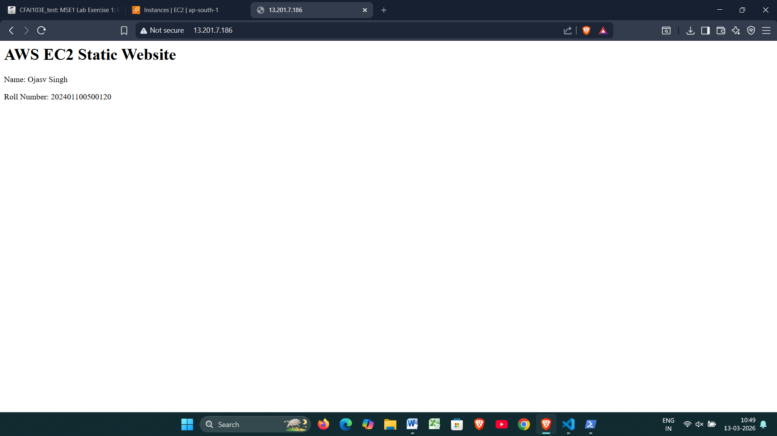
- EC2 Public IP address

13.201.7.186

